Exception Handling in Java

Before learning Exception Handling, it is important to understand what kinds of errors can occur in a program.
- Syntax Errors
- Logical Errors
- Runtime Errors

1️⃣ Syntax Errors
A syntax error occurs when the Java code violates the language rules or grammar.
These errors are detected at compile time, meaning the program will not compile until the error is fixed.
- Missing semicolons
- Incorrect keywords
- Misspelled method names
- Missing brackets
Example
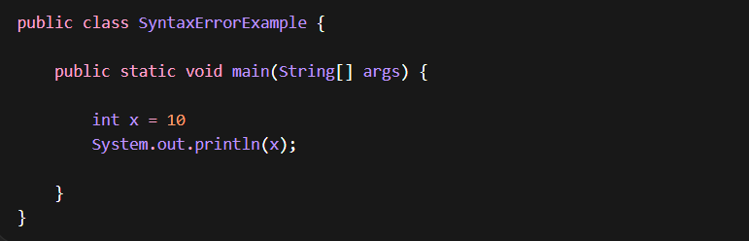
Error ';' expected
The compiler throws this error because the semicolon is missing.
Syntax errors prevent the program from compiling.

2️⃣ Logical Errors
A logical error occurs when the program runs successfully but produces incorrect output.
This happens because the logic written by the programmer is incorrect, even though the syntax is valid.
Logical errors are harder to detect because the compiler cannot identify them.
Example
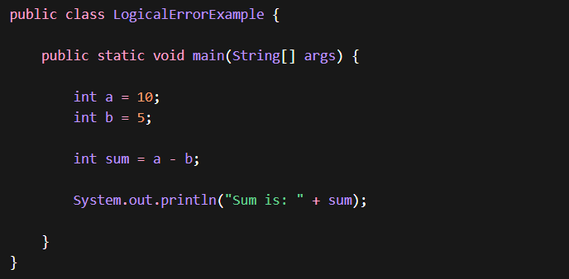
The program runs successfully, but the logic is incorrect because we intended to add numbers, not subtract them.

3️⃣ Runtime Errors
A runtime error occurs during program execution.
The code compiles successfully, but when the program runs, it encounters a problem and throws an exception. These errors occur due to:
- Invalid operations
- Incorrect user input
- Resource access problems
Example — Division by Zero
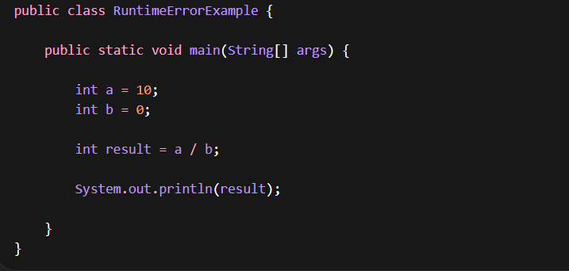
Output
The program compiles successfully, but during execution Java throws an ArithmeticException.

Another Example — Array Index Error
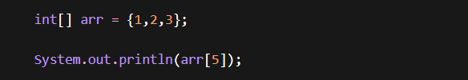
Output
ArrayIndexOutOfBoundsException
Error Type | When It Occurs | Example
Syntax Error | During compilation | Missing semicolon
Logical Error | Program runs but wrong output | Incorrect formula
Runtime Error | During execution | Division by zero

What is an Exception in Java?
An Exception is an unexpected event that occurs during the execution of a program and disrupts the normal flow of instructions.
In other words, when a program encounters a situation it cannot handle normally, Java throws an Exception object to indicate that something went wrong.
Exceptions usually occur due to:
- Invalid user input
- Arithmetic errors
- File access problems
- Network failures
- Accessing invalid memory locations
Example:
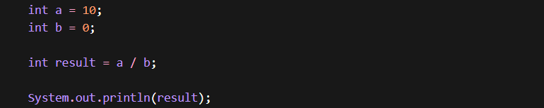
The program compiles successfully, but during execution Java detects an illegal mathematical operation.
Division by zero is not allowed, so Java throws:
ArithmeticException

What is Exception Handling in Java?
Exception Handling is a mechanism in Java used to handle runtime errors so that the normal flow of the application can be maintained.
Instead of terminating the program abruptly, exception handling allows developers to catch the error and execute alternative logic.
Java provides several constructs for exception handling:
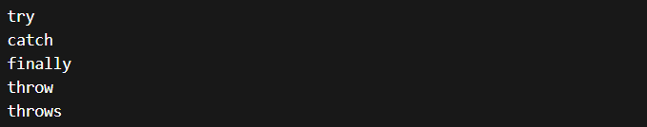

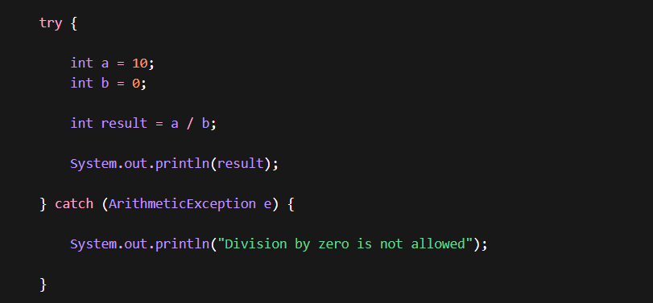
Explanation
- The risky code is placed inside the try block.
- If an exception occurs, Java transfers control to the catch block.
- The catch block handles the exception.
- The program continues execution normally.
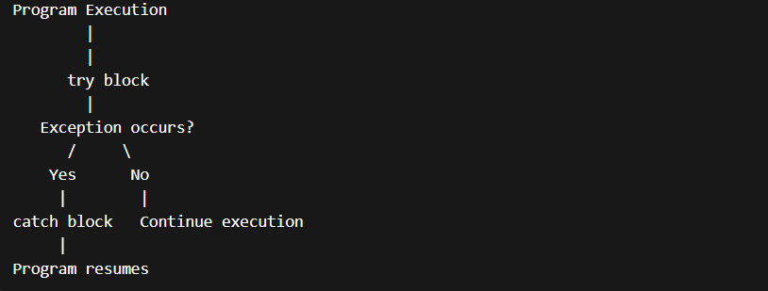
Without exception handling, the program terminates abruptly.
Exception handling allows developers to control such situations and keep the program running gracefully.
With Exception handling : program handles the problem and continues execution.

Exception vs Error
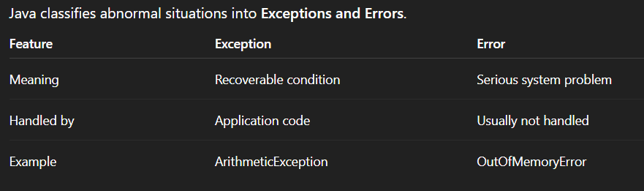
Compile-Time vs Runtime Errors
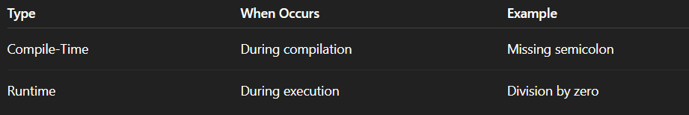
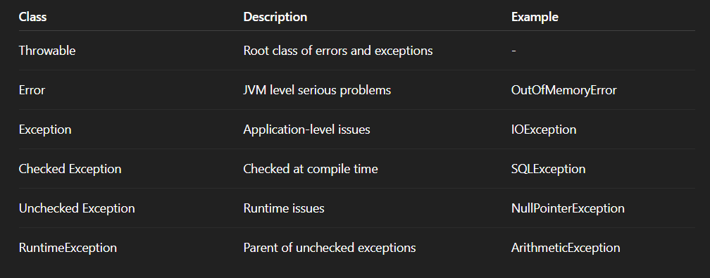

3. Exception Hierarchy
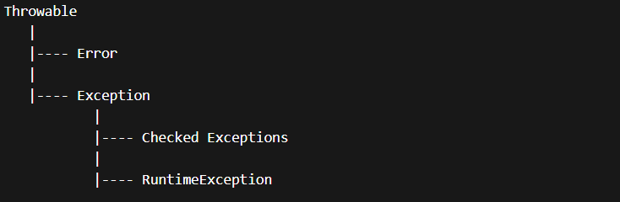
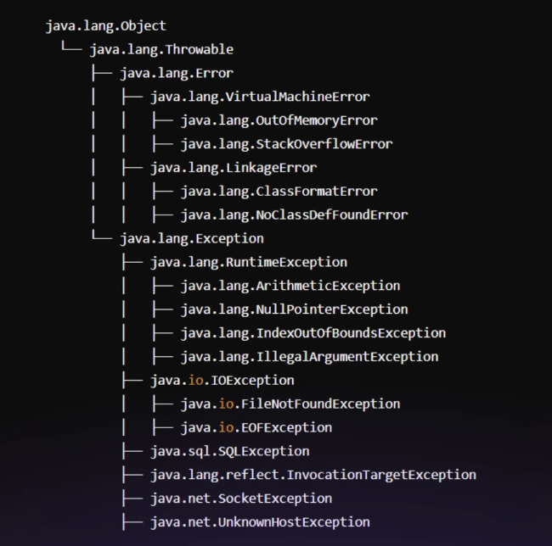
Checked Exceptions
Checked exceptions are checked by the compiler at compile time.
The programmer must handle or declare them using:
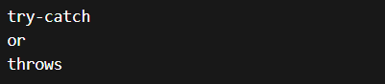
If not handled, the compiler gives an error.
Examples:
- IOException
- SQLException
- ArithmeticException
Unchecked Exceptions
Unchecked exceptions occur during runtime and are not checked by the compiler.
They usually indicate programming mistakes.
Examples:
- ArithmeticException
- NullPointerException
- ArrayIndexOutOfBoundsException
RuntimeException
RuntimeException is the parent class of all unchecked exceptions.
Examples include:
- NullPointerException
- ArithmeticException
- IndexOutOfBoundsException
- IllegalArgumentException

4. try / catch
The try-catch block is used to handle exceptions during program execution.
Risky code is placed inside the try block, and if an exception occurs, it is handled inside the catch block.
Multiple Catch Blocks
Java allows multiple catch blocks to handle different types of exceptions.
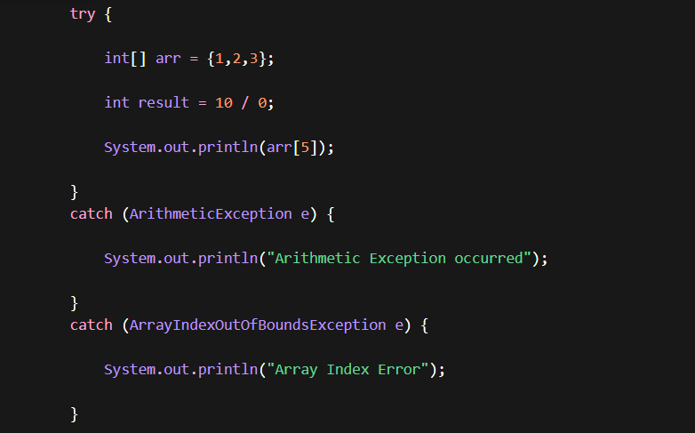
Only the first occurring exception is caught.
Catch Ordering Rule
When multiple catch blocks are used, specific exceptions must come before general exceptions.
Wrong example:
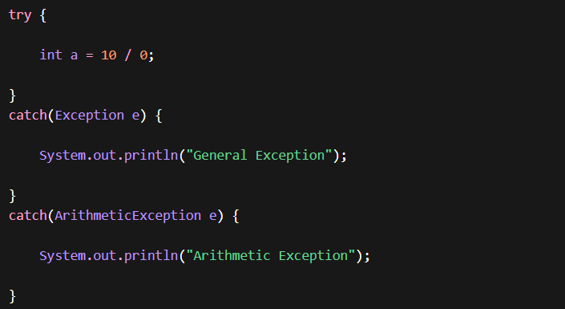

Correct ordering:
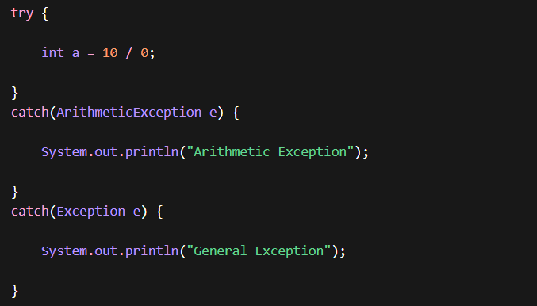
Multi-Catch (Java 7 Feature)
Java allows one catch block to handle multiple exceptions.
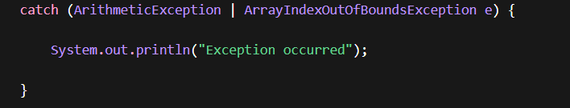
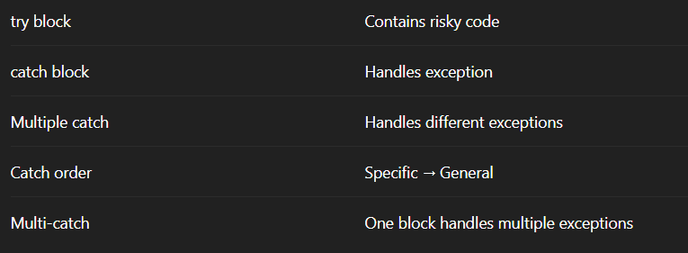
finally Block
The finally block is used to execute important cleanup code, regardless of whether an exception occurs or not.
Typical uses include:
- Closing database connections / Closing files / Releasing resources
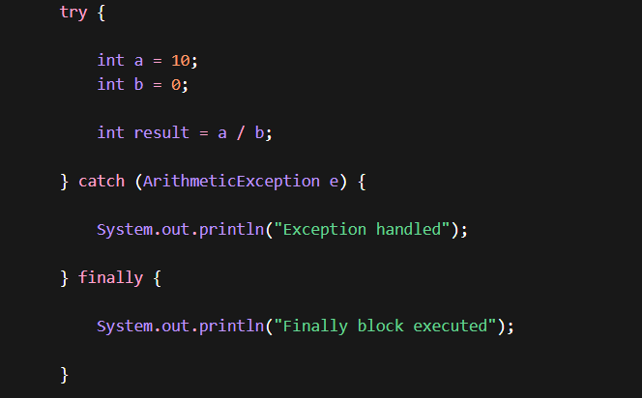
Exception handled
Finally block executed
finally Executes Even Without Exception
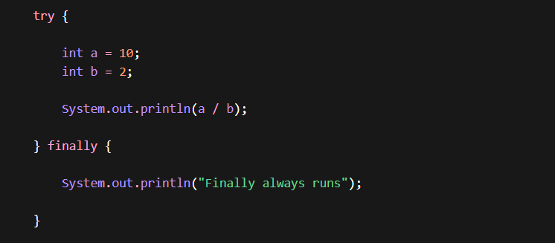
finally with return
Even if a method returns inside try, the finally block still executes.
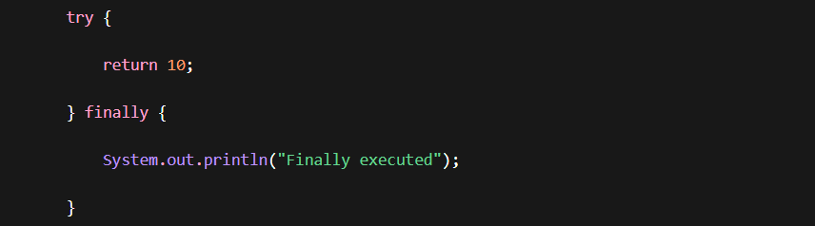
finally with Exception
If an exception occurs and is not caught, finally still executes before the program terminates.
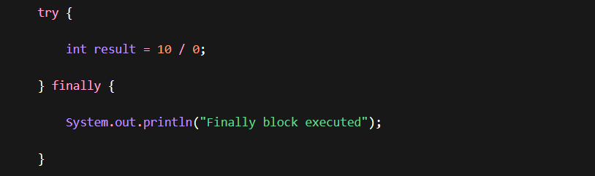
5 — throw Keyword
The throw keyword is used to explicitly throw an exception in Java.
Instead of waiting for Java to generate an exception automatically, a developer can manually throw an exception when a specific condition occurs.
1. Basic Example 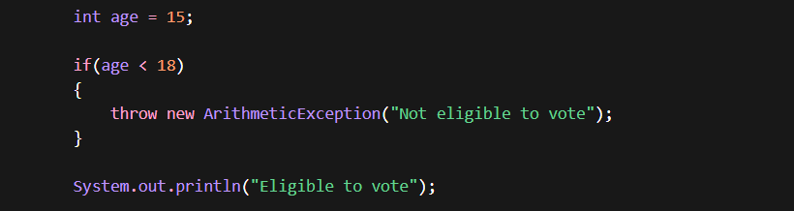
Output
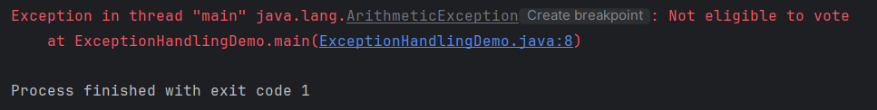
2.Using throw with try-catch
Usually throw is used with exception handling.
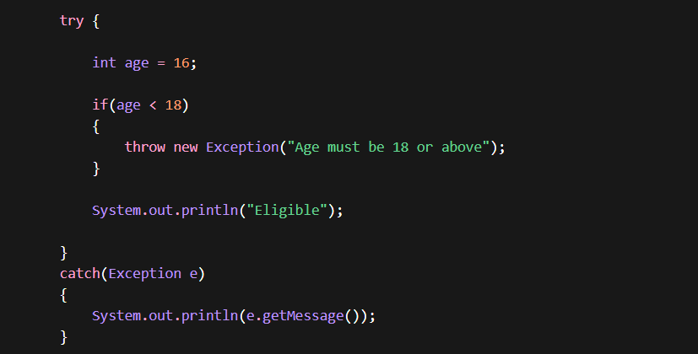
Age must be 18 or above
3. Validation Example (Common in Real Applications)
Example: Bank withdrawal validation
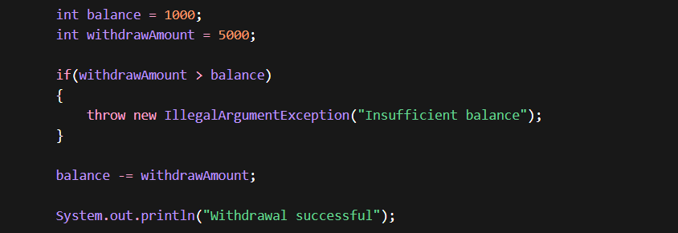Output
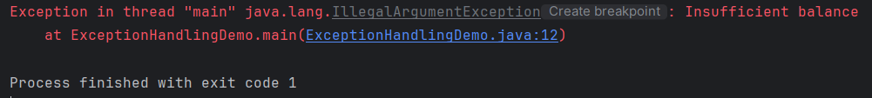This pattern is commonly used in business logic validations.

Important Notes
Concept | Explanation
throw | Used to throw an exception manually
Object required | Must throw an Exception object
Common usage | Validation checks
Works with | try-catch or throws

6 — throws Keyword
The throws keyword is used to declare exceptions in a method signature.
It tells the caller of the method that this method may throw an exception, and the caller must handle it.
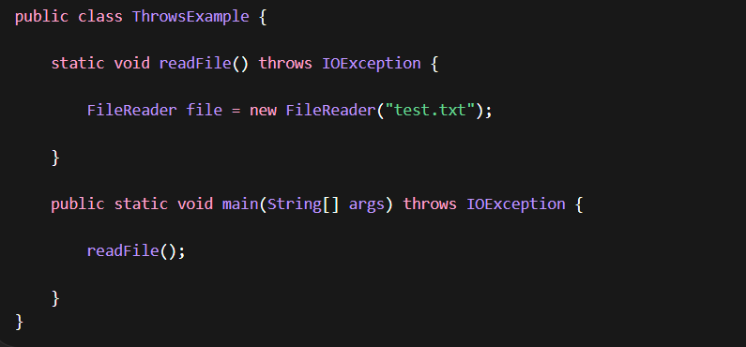
Exception Propagation
Exceptions can propagate up the call stack.
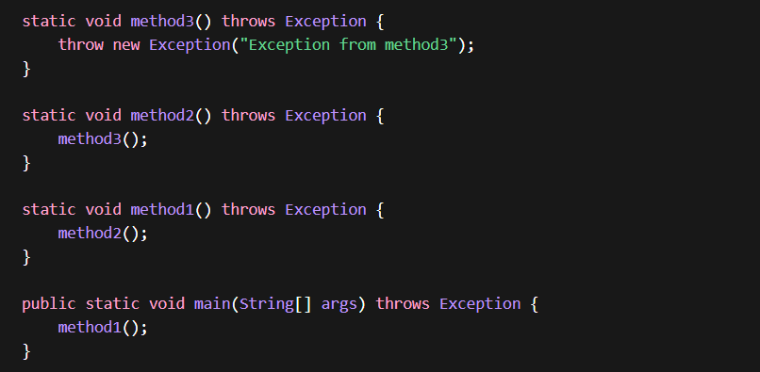

Handling throws using try-catch
Instead of propagating, we can handle the exception.
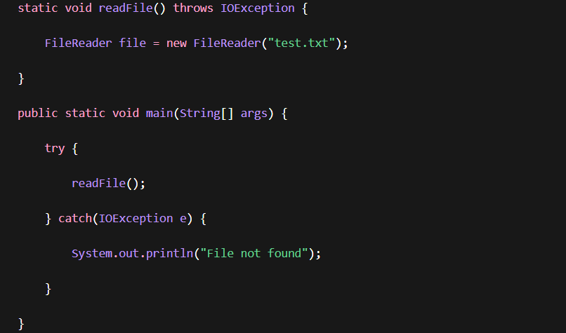
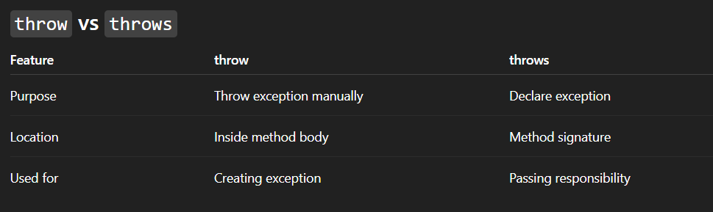
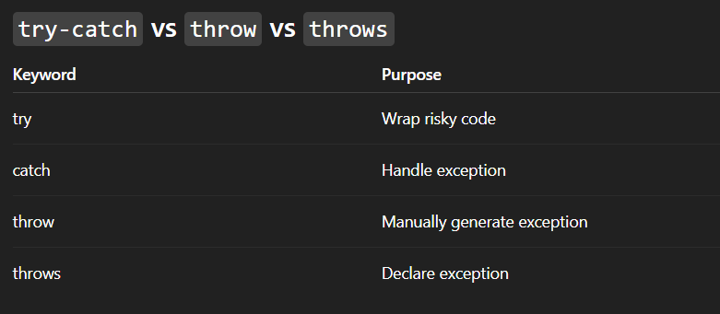
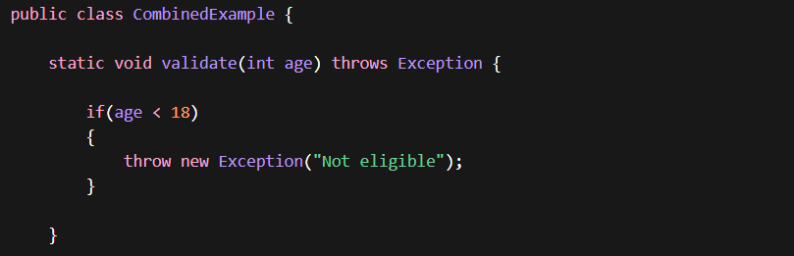
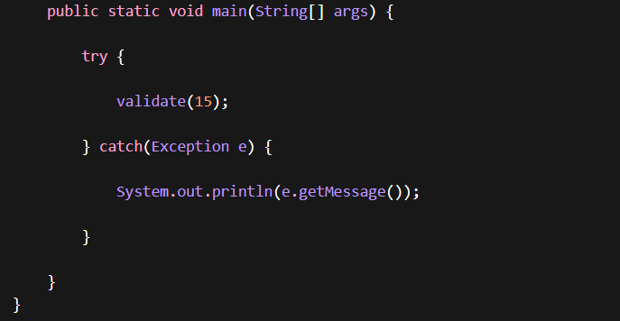

7 — Checked vs Unchecked Exceptions
Java exceptions are divided into two main categories:
- Checked Exceptions
- Unchecked Exceptions

1️⃣ Checked Exceptions
Checked exceptions are checked by the compiler at compile time.
The programmer must either handle them using try-catch or declare them using throws.
Common examples:
- IOException
- SQLException
- ClassNotFoundException
- FileNotFoundException

Example — Checked Exception
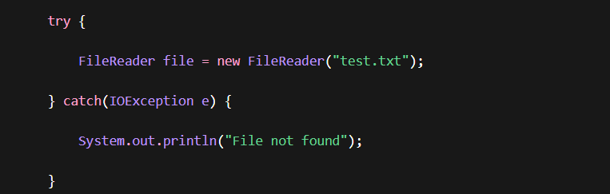
Explanation:
FileReader may throw IOException, so the compiler forces us to handle it.

Using throws
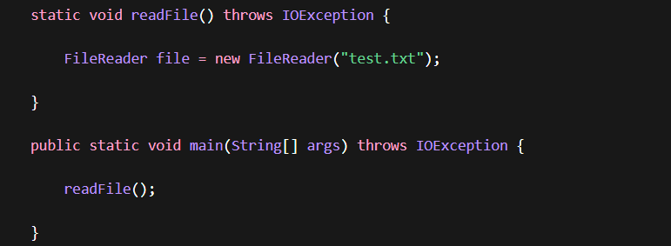

2️⃣ Unchecked Exceptions
Unchecked exceptions occur during runtime and are not checked by the compiler.
They usually happen due to programming mistakes.
Examples:
- ArithmeticException
- NullPointerException
- ArrayIndexOutOfBoundsException
- IllegalArgumentException
Example — Unchecked Exception
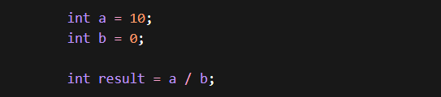
Output
ArithmeticException: / by zero
The compiler does not force handling.
Another Unchecked Example
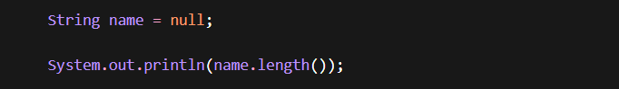Output
NullPointerException
Checked vs Unchecked Exceptions
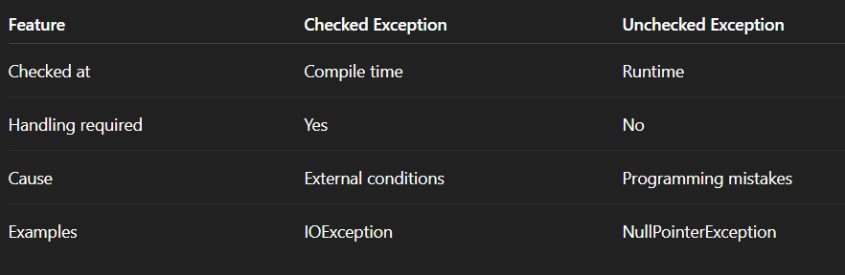

Quick Rule (Interview Tip)
Checked Exceptions → Compiler forces handling
Unchecked Exceptions → Programmer responsibility
Checked exceptions are used for recoverable situations:
- File access
- Database operations
- Network calls
Unchecked exceptions usually indicate coding errors.

8 — Custom Exceptions
Sometimes built-in exceptions are not enough to represent business problems.
In such cases, we can create our own exception class.
These are called Custom Exceptions.
Custom exceptions are commonly used for:
- Business rule validation
- Application-specific errors
- Domain logic failures

1️⃣ Creating a Custom Exception
To create a custom exception, extend the Exception class.
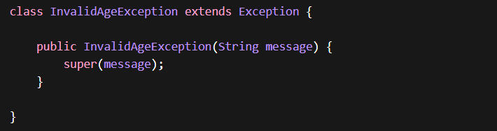Explanation:
- InvalidAgeException is a custom checked exception
- super(message) passes the message to the parent class

2️⃣ Using Custom Exception

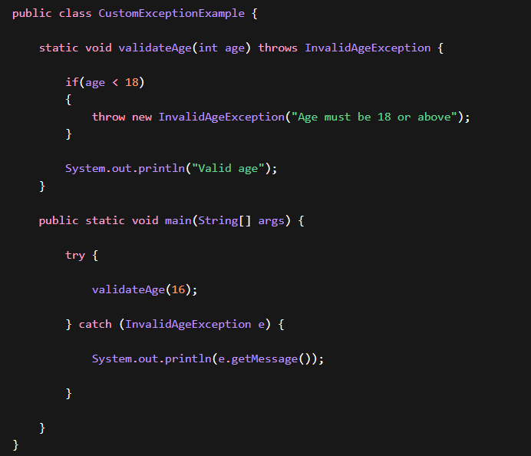Output : Age must be 18 or above
- validateAge() throws the custom exception
- main() catches and handles it
Custom Exception Flow
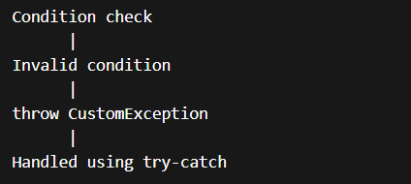
3️⃣ Custom Runtime Exception
We can also create unchecked custom exceptions by extending RuntimeException.
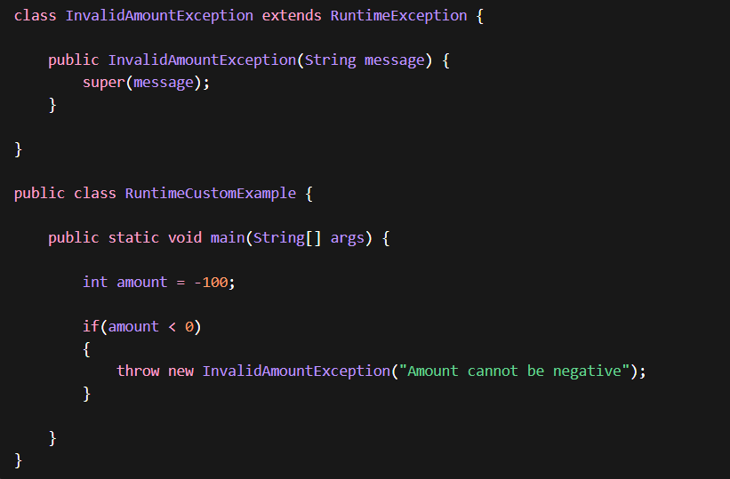
Explanation:
Since it extends RuntimeException, the compiler does not force handling.

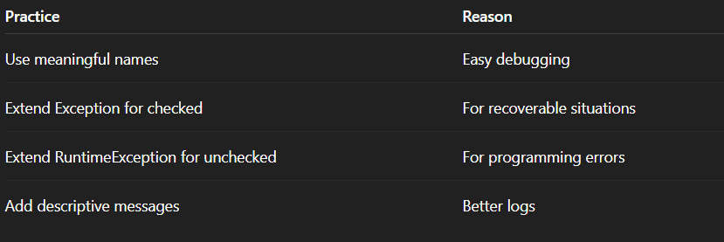

9 — try-with-resources
try-with-resources is used to automatically close resources after use.
Resources include:
- Files
- Database connections
- Network streams
Problem Without try-with-resources
Normally we must close resources manually in finally.
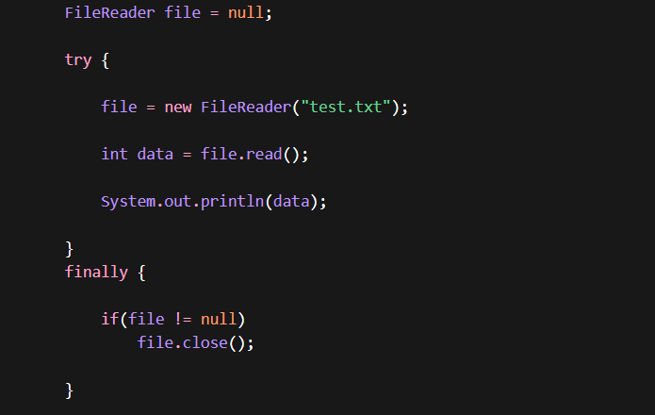
Problems:
- More code
- Easy to forget closing resources
- Resource leaks possible

Using try-with-resources
Java automatically closes resources after execution.
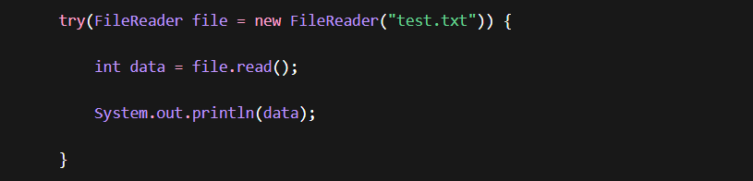
Explanation:
Resource inside try() is automatically closed.

Example with BufferedReader
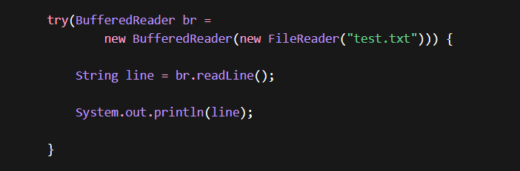
Multiple Resources
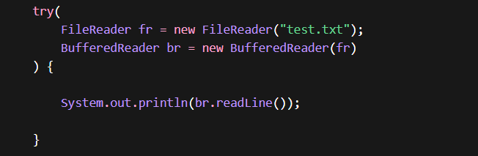

10 — Exception Handling Best Practices
When implementing exception handling in real applications, developers should follow certain best practices to keep the code clean, maintainable, and reliable.
Key Best Practices
• Avoid empty catch blocks – Always log or handle exceptions properly. Ignoring exceptions can hide critical issues.
• Catch specific exceptions instead of generic ones – Handling specific exceptions helps in debugging and maintaining better control over error handling.
• Avoid catching Throwable or Error – These represent serious JVM-level issues and usually should not be handled by application code.
• Use meaningful exception messages – Clear messages make debugging easier and improve log readability.
• Do not use exceptions for normal program flow – Exceptions should represent unexpected conditions, not regular logic decisions.
• Prefer try-with-resources for resource handling – It automatically closes resources like files, streams, and database connections.
• Log exceptions instead of just printing them – In production applications, proper logging frameworks should be used to record errors.
• Wrap lower-level exceptions when propagating them – This helps preserve the root cause while providing meaningful context at higher levels of the application.
• Create custom exceptions for business logic – Domain-specific exceptions make the code more readable and maintainable.
• Always clean up resources properly – Resources like files, streams, and database connections must be released to avoid leaks.

